Load Balancers
Task 1: Configure Classic Load Balancer
1. What is a Classic Load Balancer?
A Classic Load Balancer is AWS’s previous-generation load balancer. It distributes incoming traffic across registered EC2 instances.
It supports:
- HTTP
- HTTPS
- TCP
- SSL/TLS
A Classic Load Balancer uses registered EC2 instances directly. It does not use target groups like Application and Network Load Balancers.
It continually checks instance health and sends traffic only to healthy instances.
Architecture
Internet
|
|
Classic Load Balancer
HTTP Port 80
/ \
/ \
EC2-Web-Server-1 EC2-Web-Server-2
Apache:80 Apache:80

Part A: Check the prerequisites
You need:
Resource | Requirement
VPC | One existing VPC
Subnets | Two public subnets in different Availability Zones
EC2 instances | Two running instances
Web server | Apache installed on both
Load balancer listener | HTTP port 80
Health check | HTTP port 80
For example:
VPC: Load-Balancer-VPC
CIDR: 10.0.0.0/16

Public-Subnet-1:
10.0.1.0/24
us-east-1a

Public-Subnet-2:
10.0.2.0/24
us-east-1b
The two EC2 instances and the Classic Load Balancer must be in the same AWS Region.
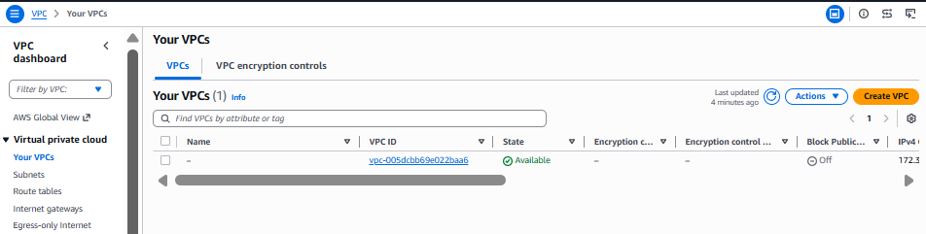
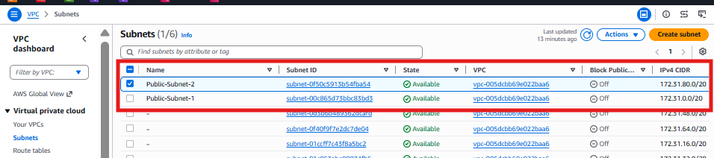
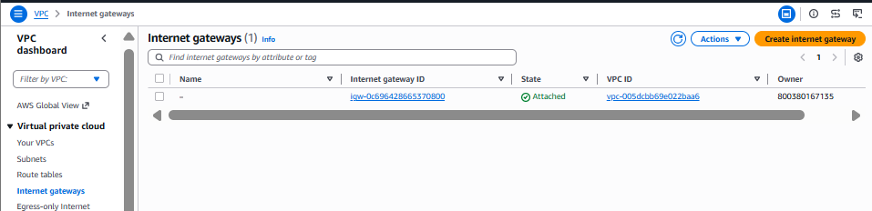
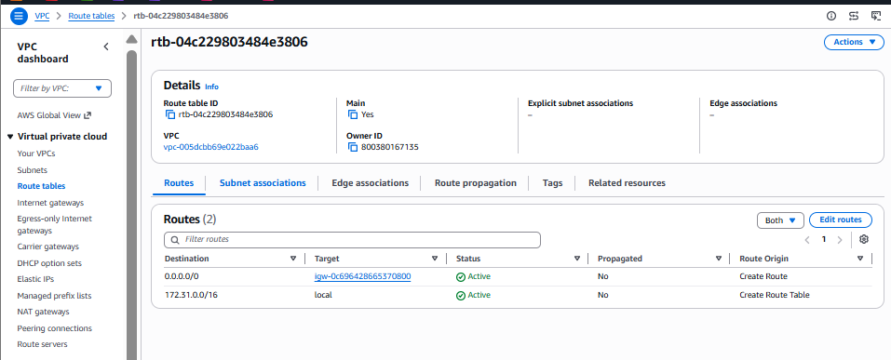

Part B: Create the load balancer security group
Go to:
AWS Console
→ EC2
→ Network & Security
→ Security Groups
→ Create security group
Enter:
Basic details
Setting | Value
Security group name | Classic-LB-SG
Description | Allow HTTP traffic to Classic Load Balancer
VPC | Select your lab VPC
Inbound rule
Click Add rule:
Type | Protocol | Port | Source
HTTP | TCP | 80 | 0.0.0.0/0
For an internet-facing load balancer, this allows users on the internet to access the load balancer.
Outbound rule
Keep the default:
Type | Destination
All traffic | 0.0.0.0/0
Click:
Create security group
AWS requires the Classic Load Balancer security group to permit traffic for its listener and health-check ports.
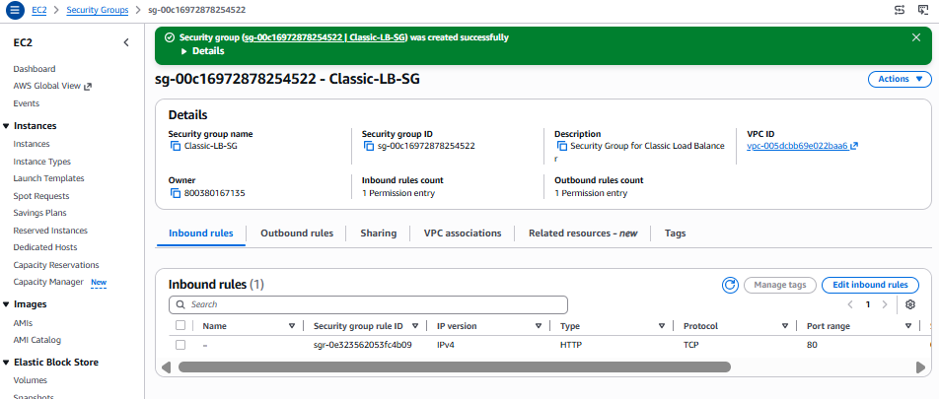

Part C: Prepare the EC2 security group
Your two EC2 servers must allow the Classic Load Balancer to reach Apache on port 80.
Go to:
EC2
→ Security Groups
→ Select the EC2 instance security group
→ Inbound rules
→ Edit inbound rules
Add:
Type | Protocol | Port | Source
HTTP | TCP | 80 | Classic-LB-SG
SSH | TCP | 22 | My IP
For HTTP, select the Classic Load Balancer security group ID as the source instead of 0.0.0.0/0.
Example:
Type: HTTP
Port: 80
Source: sg-xxxxxxxx / Classic-LB-SG
This is more secure because users cannot directly access the EC2 web servers. They must enter through the load balancer.
AWS recommends allowing the load balancer security group to reach the instance listener and health-check ports.
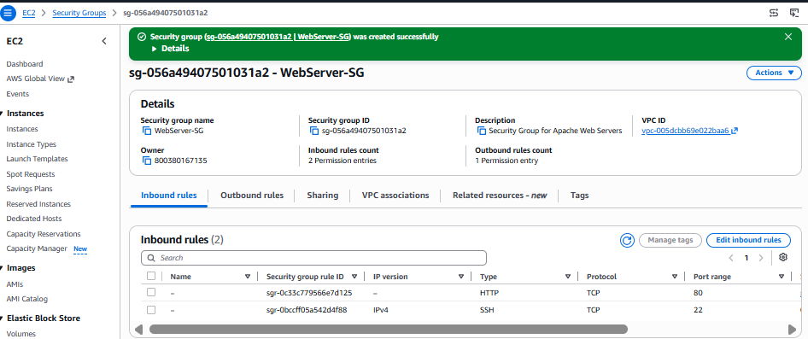

Part D: Launch the first EC2 instance
Go to:
EC2
→ Instances
→ Launch instances
Configure:
Setting | Value
Name | CLB-Web-Server-1
AMI | Amazon Linux 2023
Instance type | t3.micro
Key pair | Select your existing key
VPC | Your lab VPC
Subnet | Public Subnet 1
Auto-assign public IP | Enable
Security group | EC2 web-server security group
Expand Advanced details.
In User data, paste:
#!/bin/bash

dnf update -y
dnf install httpd -y

systemctl enable httpd
systemctl start httpd

cat <<EOF > /var/www/html/index.html
<!DOCTYPE html>
<html>
<head>
<title>Classic Load Balancer Demo</title>
</head>
<body style="font-family:Arial;text-align:center;margin-top:100px;">
<h1>Classic Load Balancer Demo</h1>
<h2>Response from Web Server 1</h2>
<p>Instance: CLB-Web-Server-1</p>
</body>
</html>
EOF
Click:
Launch instance
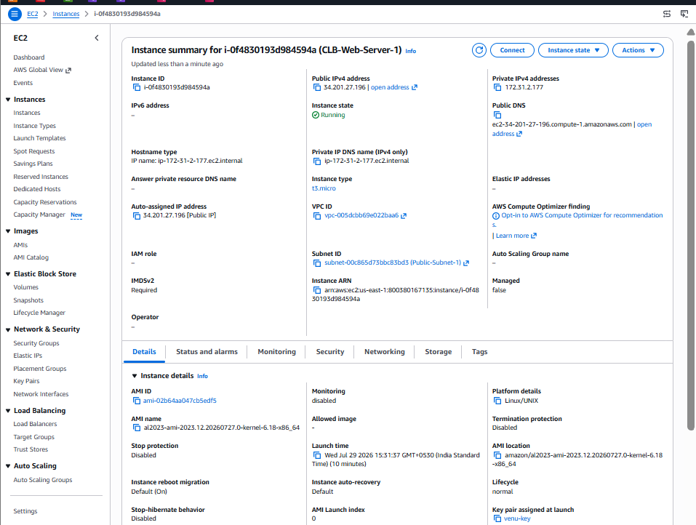

Part E: Launch the second EC2 instance
Launch another EC2 instance with:
Setting | Value
Name | CLB-Web-Server-2
AMI | Amazon Linux 2023
Instance type | t3.micro
VPC | Same VPC
Subnet | Public Subnet 2
Auto-assign public IP | Enable
Security group | Same EC2 web-server security group
Use this user data:
#!/bin/bash

dnf update -y
dnf install httpd -y

systemctl enable httpd
systemctl start httpd

cat <<EOF > /var/www/html/index.html
<!DOCTYPE html>
<html>
<head>
<title>Classic Load Balancer Demo</title>
</head>
<body style="font-family:Arial;text-align:center;margin-top:100px;">
<h1>Classic Load Balancer Demo</h1>
<h2>Response from Web Server 2</h2>
<p>Instance: CLB-Web-Server-2</p>
</body>
</html>
EOF
Click:
Launch instance
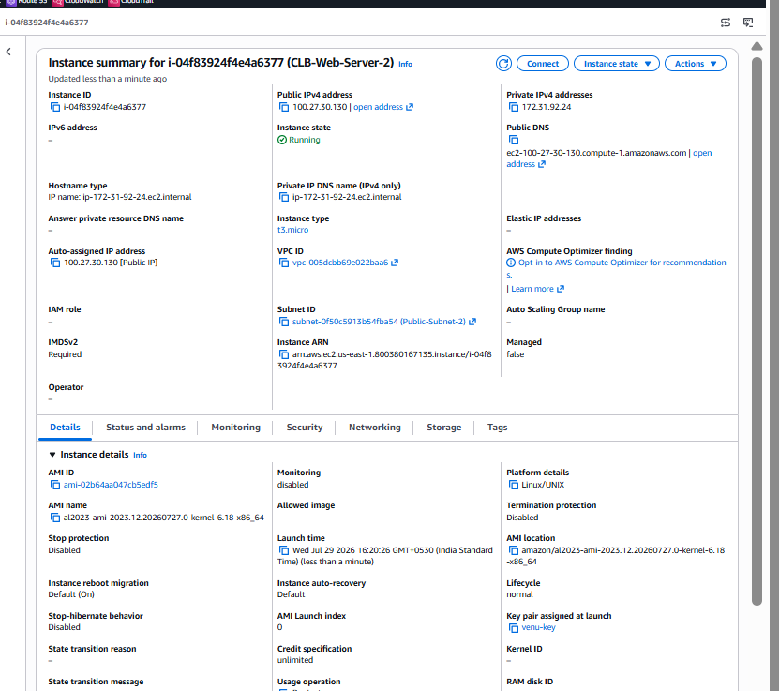

Part F: Verify Apache
Wait until both instances show:
Instance state: Running
Status checks: 3/3 checks passed
Initially, test using each instance’s public IPv4 address:
http://EC2-PUBLIC-IP
For Server 1, you should see:
Response from Web Server 1
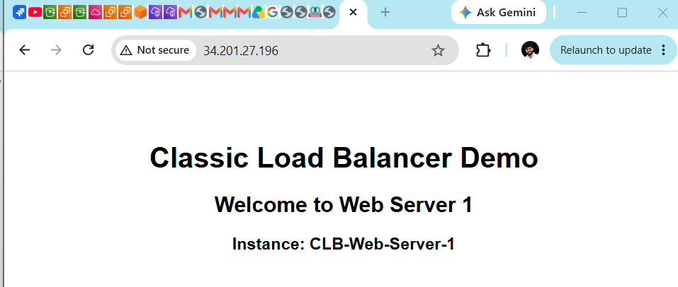
For Server 2:
Response from Web Server 2
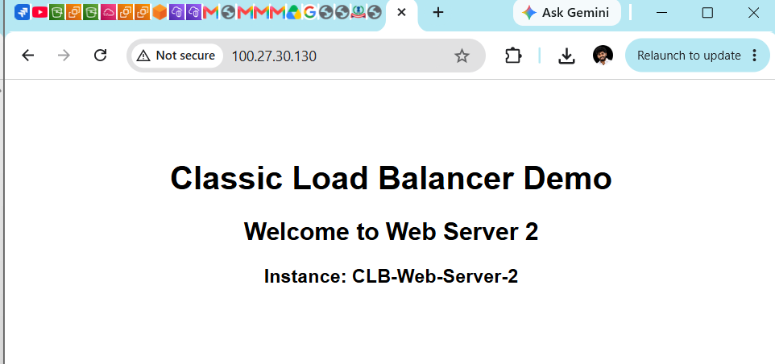
After confirming this, you can remove public HTTP access and restrict the EC2 security group to only Classic-LB-SG.

Part G: Create the Classic Load Balancer
Go to:
AWS Console
→ EC2
→ Load Balancing
→ Load Balancers
→ Create load balancer
You should see:
Application Load Balancer
Network Load Balancer
Gateway Load Balancer
Classic Load Balancer
Under Classic Load Balancer, click:
Create
Classic Load Balancer may appear under a section such as:
Previous generation load balancers

Part H: Basic configuration
Enter:
Setting | Value
Load balancer name | Classic-Web-CLB
Scheme | Internet-facing
IP address type | IPv4
VPC | Your lab VPC
The load balancer name must contain only letters, numbers and hyphens.
Do not place a hyphen at the beginning or end.

Part I: Configure listener
Configure:
Load balancer protocol | Load balancer port | Instance protocol | Instance port
HTTP | 80 | HTTP | 80
Traffic flow:
User
↓ HTTP:80
Classic Load Balancer
↓ HTTP:80
EC2 Apache server
A listener accepts connections on the configured protocol and port and forwards them to registered instances.

Part J: Select subnets
Select both public subnets:
Public-Subnet-1 – us-east-1a
Public-Subnet-2 – us-east-1b
Using subnets in multiple Availability Zones improves application availability.
Do not select two subnets from the same Availability Zone.
Example:
Correct:

us-east-1a → Public-Subnet-1
us-east-1b → Public-Subnet-2

Part K: Select security group
Choose:
Classic-LB-SG
Confirm that it allows:
HTTP
TCP
Port 80
Source 0.0.0.0/0

Part L: Configure the health check
Configure:
Setting | Value
Ping protocol | HTTP
Ping port | 80
Ping path | /
Response timeout | 5 seconds
Interval | 30 seconds
Unhealthy threshold | 2
Healthy threshold | 2
The important health-check URL is:
HTTP:80/
The load balancer will effectively request:
http://EC2-PRIVATE-IP/
The EC2 application must return:
HTTP 200 OK
Classic Load Balancers mark healthy registered instances as InService and unhealthy instances as OutOfService. Traffic is sent only to healthy instances.
Avoid using /index.html unless you are sure that file exists and returns status code 200.
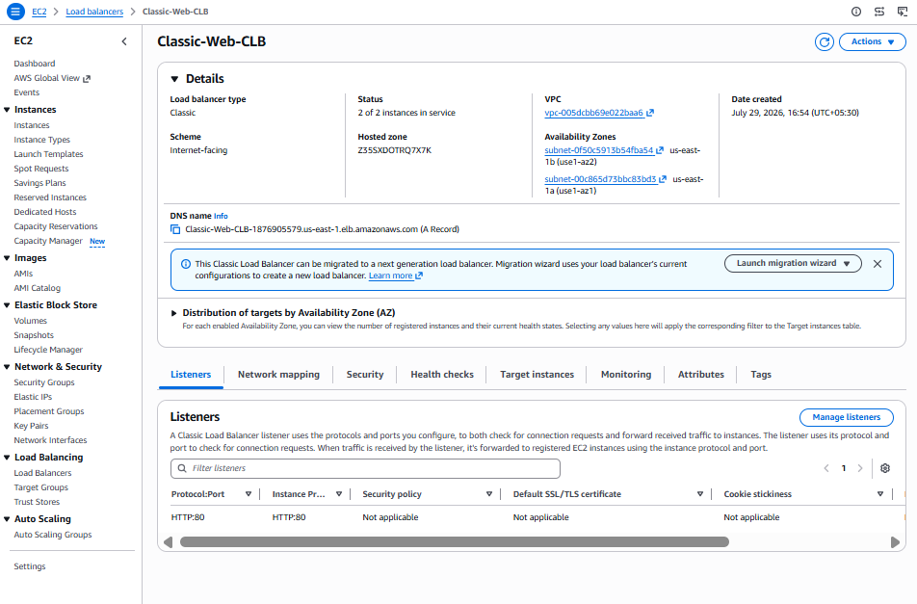

Part M: Register the EC2 instances
In the instance selection section, select:
CLB-Web-Server-1
CLB-Web-Server-2
Confirm:
Instance | Availability Zone | Port
CLB-Web-Server-1 | us-east-1a | 80
CLB-Web-Server-2 | us-east-1b | 80
Then click:
Create load balancer
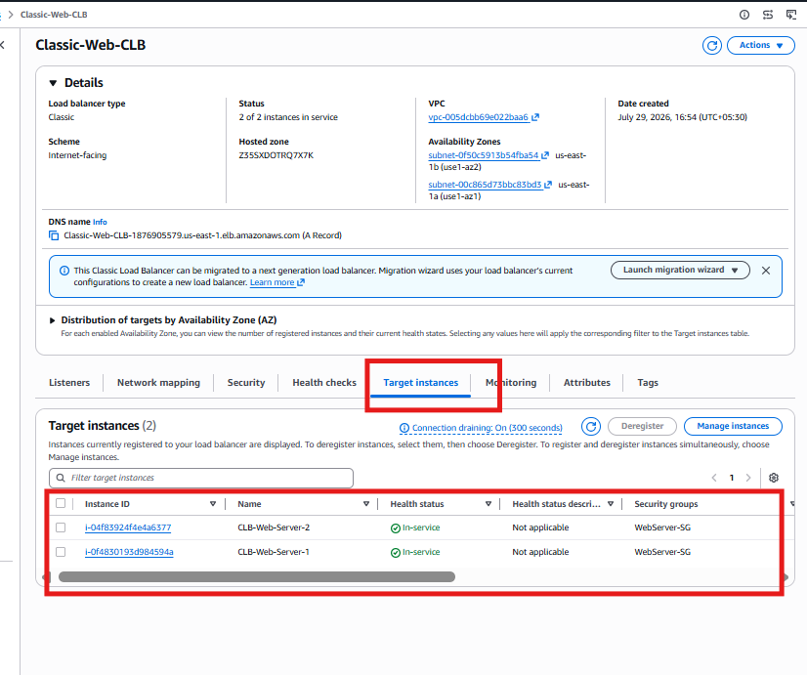

Part N: Wait for instance health
Open:
EC2
→ Load Balancers
→ Select Classic-Web-CLB
→ Instances
Initially, you may see:
OutOfService
Instance registration is still in progress
After successful health checks, you should see:
CLB-Web-Server-1 → InService
CLB-Web-Server-2 → InService
Initial registration may take a short period before health checks start succeeding. An instance does not become InService until it passes the load balancer health check.
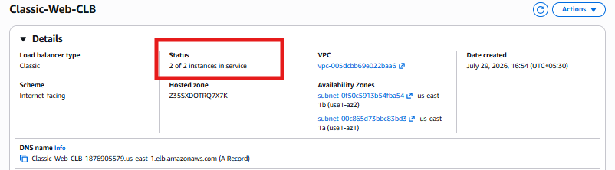

Part O: Test the Classic Load Balancer
Select the load balancer and copy its DNS name.
Example:
Classic-Web-CLB-123456789.us-east-1.elb.amazonaws.com
Open:
http://Classic-Web-CLB-123456789.us-east-1.elb.amazonaws.com
Refresh the browser several times.
You should alternately receive:
Response from Web Server 1
and:
Response from Web Server 2
The flow is:
First request
Client → CLB → Web Server 1

Second request
Client → CLB → Web Server 2
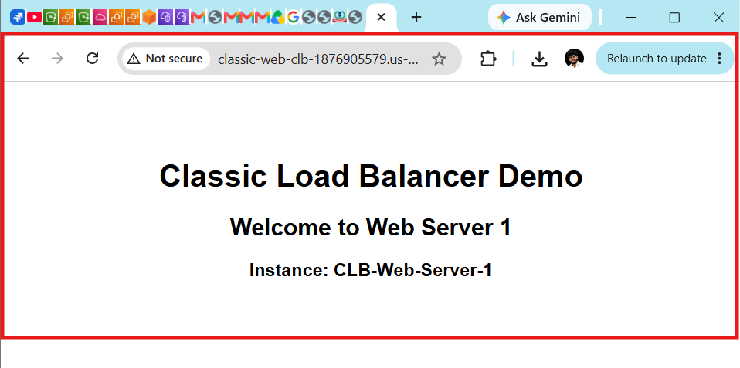
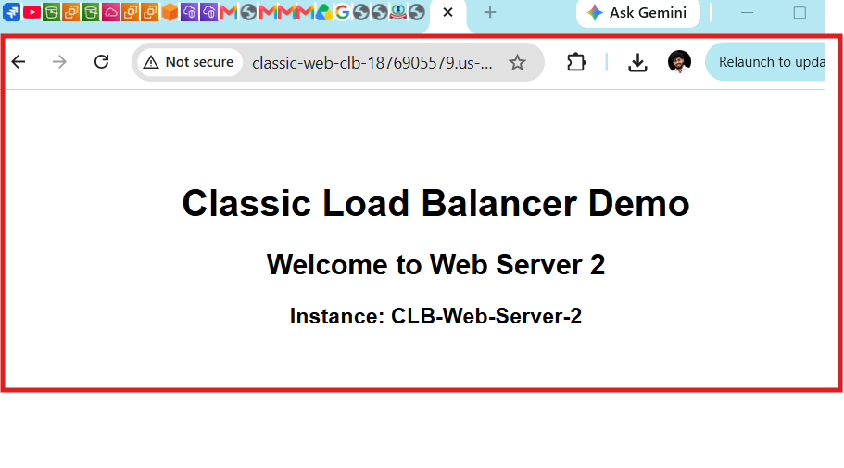

Module 2: Application Load Balancer (ALB)
What you will learn
- Create an Application Load Balancer
- Understand Target Groups
- Configure Health Checks
- Register EC2 instances
- Perform Path-based Routing
- Perform Host-based Routing
- Configure HTTPS with ACM SSL
- Enable Sticky Sessions
- Redirect HTTP → HTTPS

ALB Architecture
Internet
│
HTTPS / HTTP
│
Application Load Balancer
│
┌──────────────┴──────────────┐
│ │
Target Group-1 Target Group-2
│ │
Web Server 1 Web Server 2

Why do we need an ALB?
Suppose your company has one domain:
www.company.com
You want:
www.company.com/app1
to go to:
Web Server 1
and
www.company.com/app2
to go to:
Web Server 2
A Classic Load Balancer cannot do this.
An Application Load Balancer can.

Real-Time Example
amazon.com
Requests:
amazon.com/cart
amazon.com/orders
amazon.com/payment
amazon.com/profile
Each path can be routed to a different application or microservice.

Prerequisites
We already have:
- ✅ Default VPC
- ✅ Two Public Subnets
- ✅ Two EC2 Instances
- ✅ Apache Installed
- ✅ Security Groups
We can reuse these resources.

ALB Lab Flow
Part A : Prerequisites
Part B : Create Target Group
Part C : Register EC2 Instances
Part D : Create Application Load Balancer
Part E : Configure Listener
Part F : Configure Security Group
Part G : Health Checks
Part H : Verify Target Health
Part I : Test ALB DNS
Part J : Path-based Routing
Part K : Host-based Routing
Part L : HTTPS using ACM
Part M : HTTP → HTTPS Redirect

Part A – Prerequisites
We already have everything needed.
Resource | Status
Default VPC | ✅
Public Subnet-1 | ✅
Public Subnet-2 | ✅
CLB-Web-Server-1 | ✅
CLB-Web-Server-2 | ✅
Apache Installed | ✅
Internet Gateway | ✅
Route Table | ✅

Next Step
The first step in an Application Load Balancer is not creating the load balancer.
Instead, AWS requires you to create a Target Group first.
Why?
A Classic Load Balancer registers EC2 instances directly.
An Application Load Balancer sends traffic to a Target Group, and the Target Group forwards it to the EC2 instances.
Classic Load Balancer

CLB
│
├── EC2-1
└── EC2-2
Application Load Balancer

ALB
│
▼
Target Group
│
├── EC2-1
└── EC2-2
Part B: Create a Target Group
What is a Target Group?
A Target Group is a logical collection of backend resources (EC2 instances, IP addresses, Lambda functions, etc.) that receive traffic from the Application Load Balancer.
Architecture
Internet
│
▼
Application Load Balancer
│
▼
Target Group
┌────────┴────────┐
▼ ▼
Web Server 1 Web Server 2
Why do we need a Target Group?
The ALB does not send traffic directly to EC2 instances.
Instead:
Client
│
▼
Application Load Balancer
│
▼
Target Group
│
▼
EC2 Instances
This allows:
- Path-based routing
- Host-based routing
- Health checks
- Multiple applications behind one ALB

Step 1: Open Target Groups
Go to:
AWS Console
→ EC2
→ Load Balancing
→ Target Groups
Click:
Create target group

Step 2: Choose Target Type
You'll see several options.
Select:
Option | Value
Target type | Instances
Why "Instances"?
Because our backend consists of EC2 instances.
Other options:
Target Type | Used For
Instances | EC2 servers
IP addresses | On-premises or external servers
Lambda | AWS Lambda functions
Application Load Balancer | Chaining ALBs

Step 3: Basic Configuration
Fill in the following values:
Setting | Value
Target group name | ALB-Web-TG
Protocol | HTTP
Port | 80
IP address type | IPv4

Step 4: Select VPC
Choose:
Setting | Value
VPC | vpc-005dcbb69e022baa6 (default)

Step 5: Health Check Settings
Keep these values:
Setting | Value
Health check protocol | HTTP
Health check path | /
Port | Traffic port
Healthy threshold | 5
Unhealthy threshold | 2
Timeout | 5 seconds
Interval | 30 seconds
Success codes | 200
How it works
The Target Group checks each EC2 instance:
HTTP://EC2-Private-IP:80/
If the response is:
HTTP 200 OK
the instance is marked Healthy.

Step 6: Advanced Health Check Settings
Leave the defaults:
Setting | Value
Deregistration delay | 300 seconds
Load balancing algorithm | Round Robin
Slow start | Disabled
Stickiness | Disabled
We'll configure Stickiness later.

Step 7: Click "Next"
Do not register the instances yet.
We'll register them in Part C.

Expected Summary
Setting | Value
Target Group Name | ALB-Web-TG
Target Type | Instances
Protocol | HTTP
Port | 80
VPC | Default
Health Check | HTTP /
Success Code | 200
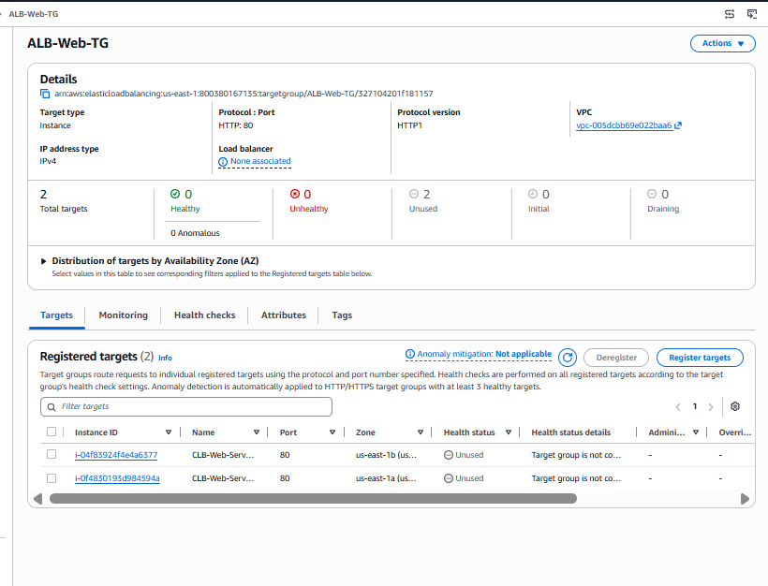

Part C – Register EC2 Instances to Target Group ✅
Purpose: Register backend EC2 instances so the Target Group knows where to send traffic.
Step 1
Select:
CLB-Web-Server-1
Step 2
Select:
CLB-Web-Server-2
Step 3
Routing Port:
80
Step 4
Click:
Include as pending below
You should see:
Registered Targets

CLB-Web-Server-1
Port 80

CLB-Web-Server-2
Port 80
Step 5
Click:
Create Target Group

Why did your targets show "Unused"?
Your screenshot showed:
Health Status

Unused
Reason:
Target group is not configured to receive traffic from the load balancer.
This is expected because there is no Application Load Balancer attached yet.
Current architecture:
Internet

(No ALB)

ALB-Web-TG
│
┌─┴─────────┐
▼ ▼
Web1 Web2
After we create the ALB, it becomes:
Internet
│
▼
Application Load Balancer
│
▼
ALB-Web-TG
│
┌───┴────┐
▼ ▼
Web1 Web2
Then the status changes:
Unused

↓

Initial

↓

Healthy

Part D – Create the Application Load Balancer
Objective
Create an Application Load Balancer and connect it to the ALB-Web-TG target group.
Architecture
Internet
│
▼
Application Load Balancer
│
▼
ALB-Web-TG
┌───────────┐
▼ ▼
CLB-Web-Server-1 CLB-Web-Server-2

Step 1: Open Load Balancers
Go to:
AWS Console
→ EC2
→ Load Balancing
→ Load Balancers
Click:
Create Load Balancer

Step 2: Select Load Balancer Type
Choose:
Application Load Balancer
Click:
Create

Step 3: Basic Configuration
Fill in these values:
Setting | Value
Load Balancer Name | ALB-Web-LB
Scheme | Internet-facing
IP address type | IPv4
Why?
- Internet-facing → Users on the internet can access your application.
- IPv4 → Your EC2 instances use IPv4 addresses.

Step 4: Network Mapping
Select:
Setting | Value
VPC | vpc-005dcbb69e022baa6
Availability Zone 1 | us-east-1a
Subnet | Public-Subnet-1
Availability Zone 2 | us-east-1b
Subnet | Public-Subnet-2
Why two Availability Zones?
If one Availability Zone goes down, the ALB continues serving traffic through the other, providing high availability.

Step 5: Security Group
For this lab, select:
Classic-LB-SG
Note: Although the name is Classic-LB-SG, it is just a security group that allows HTTP traffic. It can be reused for this ALB lab. In production, you would normally create a separate security group such as ALB-SG.
Expected inbound rule:
Type | Port | Source
HTTP | 80 | 0.0.0.0/0
Part E: Configure Listener
You have:
HTTP :80
This is correct.

Default Action
Now look at this section:
Forward to target group
Select Target Group
Choose:
ALB-Web-TG
Your listener should become:
HTTP:80
│
▼
Forward to

ALB-Web-TG

Why?
Unlike the Classic Load Balancer:
CLB
│
├── EC2-1
└── EC2-2
The Application Load Balancer works like this:
ALB
│
▼
Target Group
│
├── EC2-1
└── EC2-2

Part F: Target Group Stickiness
Leave:
Turn on target group stickiness

OFF
We'll learn Stickiness later.

Part G: Tags
Skip.

Part H: Service Integrations
Leave all of these disabled:
- CloudFront
- AWS WAF
- Global Accelerator
We will configure these separately in later labs.

Review
Everything should look like this:
Setting | Value
Name | ALB-Web-LB
Scheme | Internet-facing
IPv4 | Yes
VPC | Default
Public-Subnet-1 | Yes
Public-Subnet-2 | Yes
Security Group | Classic-LB-SG
Listener | HTTP:80
Default Action | Forward to ALB-Web-TG
Target Group | ALB-Web-TG

Click
Create Load Balancer
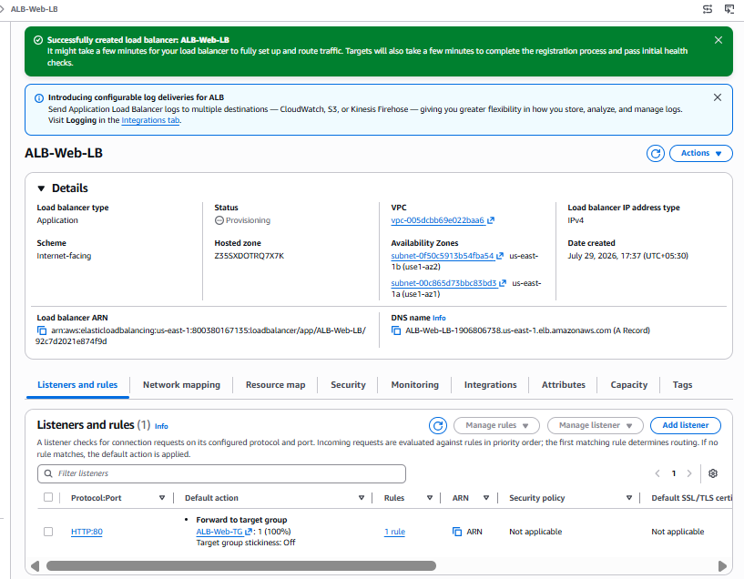

What Happens Next?
AWS creates:
Internet
│
▼
Application Load Balancer
│
▼
ALB-Web-TG
│
┌───┴────┐
▼ ▼
Web1 Web2
The Target Group status changes:
Unused

↓

Initial
↓
Healthy

After Creation
Go to:
EC2
→ Load Balancers
→ ALB-Web-LB
Wait until the status is:
Active
Then go to:
EC2
→ Target Groups
→ ALB-Web-TG
→ Targets
Both instances should become:
Healthy
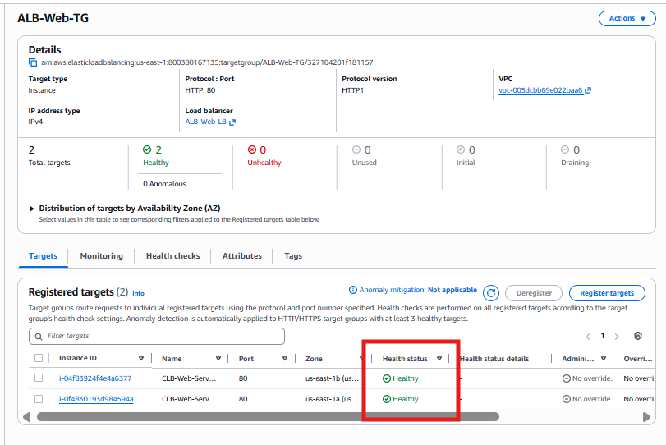

Part H – Test the Application Load Balancer
Step 1: Open the ALB
Go to:
AWS Console
→ EC2
→ Load Balancers
→ ALB-Web-LB
Copy the DNS name.
It will look like:
ALB-Web-LB-123456789.us-east-1.elb.amazonaws.com

Step 2: Open the DNS
Open:
http://YOUR-ALB-DNS
For example:
http://ALB-Web-LB-123456789.us-east-1.elb.amazonaws.com

Step 3: Refresh the Browser
Refresh the page several times.
You should see:
Welcome to Web Server 1
and
Welcome to Web Server 2
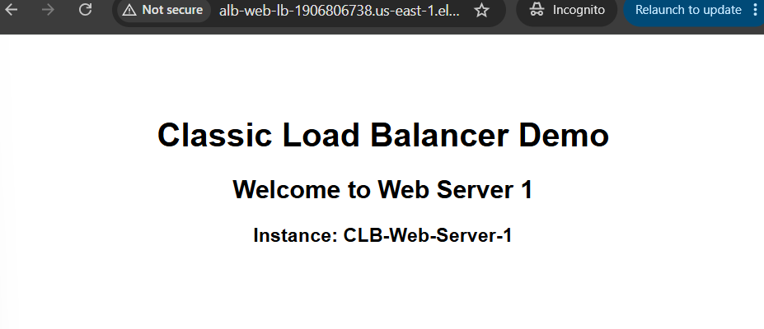
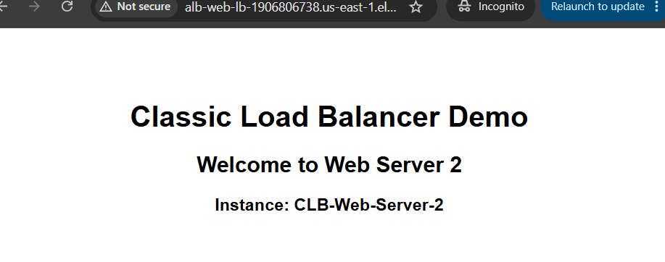

Architecture
Internet
│
▼
Application Load Balancer
HTTP :80
│
▼
ALB-Web-TG
┌─────────────┐
▼ ▼
CLB-Web-Server-1 CLB-Web-Server-2

How ALB Processes a Request
User
│
▼
Application Load Balancer
│
▼
Listener (HTTP:80)
│
▼
Listener Rule
│
▼
Target Group (ALB-Web-TG)
│
▼
Healthy EC2 Instance

Module 3: Network Load Balancer (NLB)
Learning Objectives
By the end of this lab, you'll understand:
- What is a Network Load Balancer?
- Why do we need it?
- Layer 4 (Transport Layer) load balancing
- TCP vs UDP
- Static IP support
- Elastic IP support
- Ultra-low latency
- Millions of requests handling
- Health checks
- Real-world use cases
- Hands-on creation

Topic 1: What is a Network Load Balancer?
A Network Load Balancer (NLB) distributes traffic at Layer 4 (Transport Layer) using:
- TCP
- UDP
- TLS
Unlike an ALB, it does not inspect HTTP requests. It only looks at the IP address and port number.

Real-Life Example
Imagine a courier company.
ALB (Smart Receptionist)
A receptionist asks:
"Which department do you want?"
If you say:
/payments
you go to the Payments team.
If you say:
/orders
you go to the Orders team.
The receptionist understands the request.

NLB (Security Gate)
A security guard only checks:
- Destination building
- Gate number
He doesn't care what is inside the parcel.
That's how an NLB works.

Layer Comparison
Application Layer (Layer 7)
▲
│
│ ALB
────────┼──────────────────
Transport Layer (Layer 4)
▲
│
│ NLB
────────┼──────────────────
Network Layer (Layer 3)

ALB vs NLB
Feature | ALB | NLB
OSI Layer | Layer 7 | Layer 4
Protocols | HTTP, HTTPS | TCP, UDP, TLS
Reads URL | ✅ Yes | ❌ No
Reads Host Header | ✅ Yes | ❌ No
Path-Based Routing | ✅ Yes | ❌ No
Host-Based Routing | ✅ Yes | ❌ No
Static IP | ❌ No | ✅ Yes
Elastic IP | ❌ No | ✅ Yes
Performance | High | Very High
Latency | Low | Ultra Low
Best For | Web Applications | Gaming, Databases, Banking, IoT

Why Do We Need NLB?
Suppose you have:
Internet
│
▼
Payment Gateway
│
▼
Banking Server
The application communicates using TCP.
There are no URLs like:
/login
or
/products
It simply opens a TCP connection.
An ALB cannot make routing decisions based on URLs here because there are none.
An NLB simply forwards the TCP connection.

Real-World Use Cases
Banking
ATM
│
▼
Network Load Balancer
│
▼
Banking Servers

Online Gaming
Players
│
▼
Network Load Balancer
│
▼
Game Servers

IoT Devices
Sensors
│
▼
Network Load Balancer
│
▼
Processing Servers

Databases
Applications
│
▼
Network Load Balancer
│
▼
Database Cluster

Why is NLB Faster?
ALB performs:
Read HTTP
Read URL
Read Host Header
Evaluate Rules
Choose Target Group
NLB performs:
TCP Connection
↓
Forward
Since it doesn't inspect HTTP requests, it has lower latency.

Static IP Address
One of the biggest advantages of NLB is that it supports static IP addresses (using Elastic IPs for internet-facing NLBs).
Example:
Client Firewall

Allow:

18.xx.xx.xx
With an NLB, that IP can remain fixed, which is useful when customers or partners whitelist your service.

Interview Question
Q1. When should you use an NLB instead of an ALB?
Use an NLB when you need:
- TCP/UDP/TLS load balancing
- Very low latency
- High throughput
- Static IP addresses
- Elastic IP support
- Non-HTTP applications

Hands-on Lab Roadmap
We'll build the NLB from scratch in the next steps:
Part A → Create Network Target Group
↓
Part B → Register EC2 Instances
↓
Part C → Create Network Load Balancer
↓
Part D → Configure TCP Listener
↓
Part E → Attach Target Group
↓
Part F → Verify Health Checks
↓
Part G → Test NLB DNS

Part A – Create Network Target Group
Objective
Create a Target Group that the Network Load Balancer will use to forward TCP traffic.

Step 1: Open Target Groups
Go to:
AWS Console
→ EC2
→ Target Groups
Click:
Create Target Group

Step 2: Basic Configuration
Select the following:
Setting | Value | Why?
Target type | Instances | We'll register EC2 instances
Target Group Name | NLB-Web-TG | Easy to identify
Protocol | TCP | NLB works at Layer 4
Port | 80 | Apache is listening on port 80
IP address type | IPv4 | Our EC2 instances use IPv4
VPC | vpc-005dcbb69e022baa6 (default) | Same VPC as the EC2 instances

Why TCP Instead of HTTP?
ALB
Client
│
HTTP Request
(GET /index.html)
│
▼
ALB
ALB understands:
- URLs
- Headers
- Cookies
- HTTP methods

NLB
Client
│
TCP Connection
│
▼
NLB
NLB does not inspect HTTP requests. It simply forwards the TCP connection.

Step 3: Health Check
Although the target group protocol is TCP, configure the health check as follows:
Setting | Value
Health check protocol | HTTP
Health check path | /
Port | Traffic port
Why use an HTTP health check?
A TCP health check only verifies that port 80 is open.
An HTTP health check verifies that:
- Apache is running.
- The web application responds correctly with an HTTP status (such as 200 OK).
This provides a more meaningful health check for a web server.

Step 4: Advanced Health Check Settings
Leave the defaults:
Setting | Value
Healthy threshold | 5
Unhealthy threshold | 2
Timeout | Default
Interval | Default
Success codes | 200

Expected Configuration Summary
Setting | Value
Target Type | Instances
Name | NLB-Web-TG
Protocol | TCP
Port | 80
Health Check | HTTP
Health Check Path | /
VPC | Default

Part B – Register EC2 Instances
You should now see both instances.
Select:
✅ CLB-Web-Server-1
✅ CLB-Web-Server-2
Routing Port:
80
Click:
Include as pending below
You should see:
CLB-Web-Server-1 Port 80
CLB-Web-Server-2 Port 80
Then click:
Create Target Group
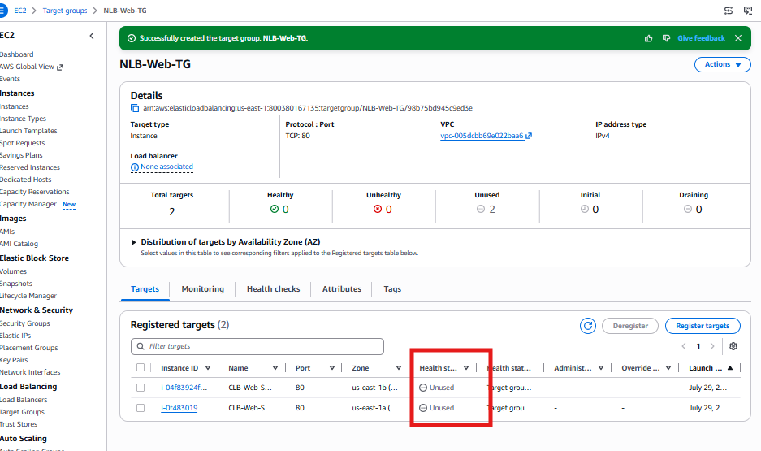

Expected Result
After creation, you'll initially see:
Health Status

Unused
Don't worry—that's expected.
Just like the ALB lab, the target group is not yet attached to a Network Load Balancer.

Part C – Create Network Load Balancer
Objective
Create an Internet-facing Network Load Balancer and attach it to the NLB-Web-TG target group.

Step 1: Open Load Balancers
Go to:
AWS Console
→ EC2
→ Load Balancers
Click:
Create Load Balancer

Step 2: Select Load Balancer Type
Choose:
Network Load Balancer
Click:
Create

Step 3: Basic Configuration
Fill in the following:
Setting | Value
Name | NLB-Web-LB
Scheme | Internet-facing
Load balancer IP address type | IPv4
Why Internet-facing?
Internet
│
▼
Network Load Balancer
Anyone on the Internet can access the application.

Step 4: Network Mapping
Select:
Setting | Value
VPC | vpc-005dcbb69e022baa6 (default)
Availability Zone 1 | us-east-1a
Subnet | Public-Subnet-1
Availability Zone 2 | us-east-1b
Subnet | Public-Subnet-2
Leave Elastic IPs unassigned for this lab.
Why no Elastic IP?
NLB supports static IPs through Elastic IPs, but they are optional. We'll learn Elastic IP integration in a later exercise.

Step 5: Listener
Configure:
Setting | Value
Protocol | TCP
Port | 80
Why TCP?
NLB operates at Layer 4, forwarding TCP connections without inspecting HTTP requests.

Step 6: Default Action
Choose:
Forward to target group
Select:
NLB-Web-TG
Your listener should look like:
TCP:80
│
▼
Forward to

NLB-Web-TG

Step 7: Review
Verify the configuration:
Setting | Expected
Name | NLB-Web-LB
Scheme | Internet-facing
IPv4 | Yes
VPC | Default
Public-Subnet-1 | Yes
Public-Subnet-2 | Yes
Listener | TCP:80
Target Group | NLB-Web-TG

Step 8: Create
Click:
Create Load Balancer

Expected Result
After a minute or two:
- NLB State → Active
- Target Group → Both EC2 instances become Healthy

